

**Dr. D. Y. Patil Institute of Engineering, Management & Research, Akurdi , Pune – 411044.**

**Department of Electronics and Telecommunication Engineering**

**JavaScript (Lab Practice – 2)**

**LAB MANUAL**

**Code: 404187**

**B.E. E&TC**

**Academic Year 2022-23**

**INDEX**

|  |  |  |
| --- | --- | --- |
| **S.No.** | **Name of the Experiment** | **Page No.** |
| 1 | Write a JavaScript program to calculate area of triangle, area of rectangle and area of circle |  |
| 2 | Write a JavaScript program to generate the multiplication table of a given number |  |
| 3 | Write a JavaScript program to following operations on a given string,  • Reverse string  • Replace characters of a string.  • String is Palindrome. |  |
| 4 | Write a JavaScript program to compare two strings using various methods. |  |
| 5 | Write a JavaScript program that will create a countdown timer |  |
| 6 | Write a JavaScript program that will create an array and perform following operations  • To remove specific element from the array.  • Check if an array contains a specified value.  • To empty an array |  |
| 7 | Write a JavaScript program that will append an object to an array and will check if an object is an array |  |
| 8 | Write a JavaScript program to create a Home page of any website and change background color using  • On mouse over event  • On focus event |  |
| 9 | Design and implement a simple calculator using Java script for operations like addition multiplication, subtraction, division, square of a number etc: • Design a calculator like text field for input and output, buttons for numbers and operations etc.  • Validate input values  • Prompt / Alerts for invalid values etc. |  |
| 10 | Virtual Lab : [https://cse02-iiith.vlabs.ac.in/List%20of%20experiments.html](https://cse02-iiith.vlabs.ac.in/List of experiments.html) |  |

**Experiment No: 01**

**Aim:-** Write a JavaScript program to calculate area of triangle, area of rectangle and area of circle.

**Algorithm :**

**Program Code:**

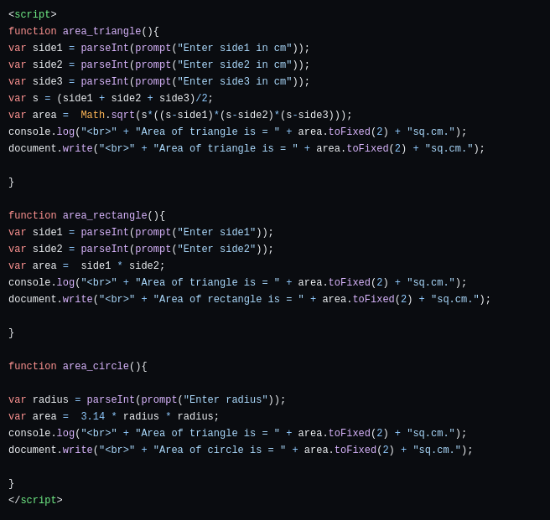

**Output:**

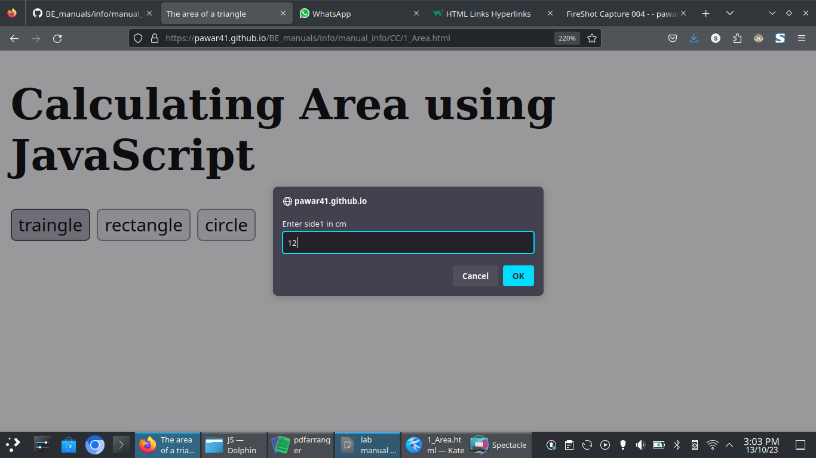

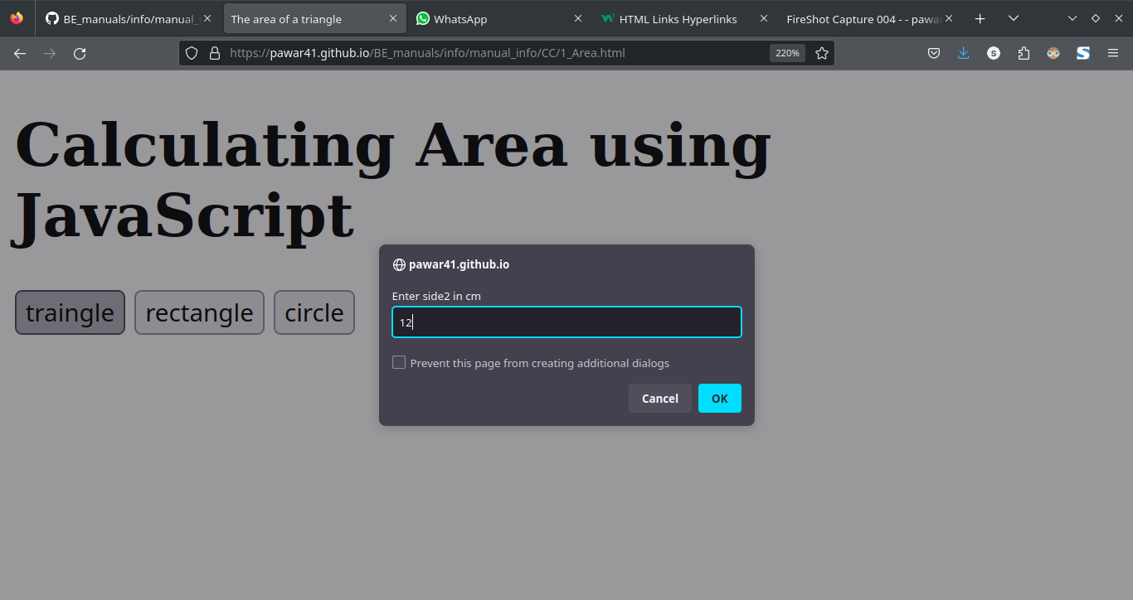

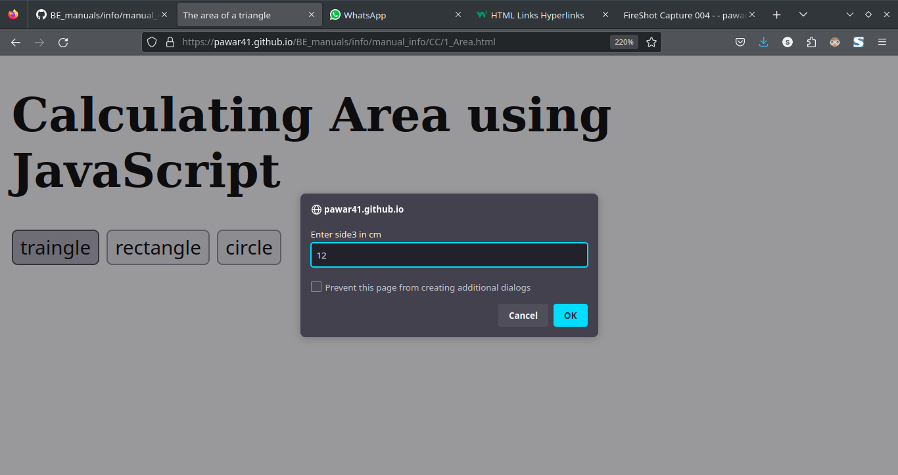

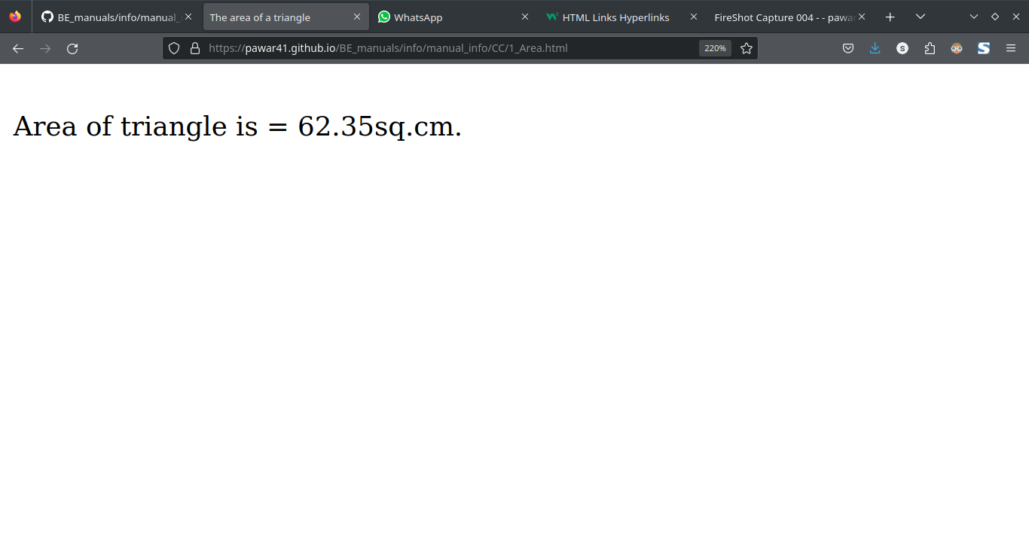

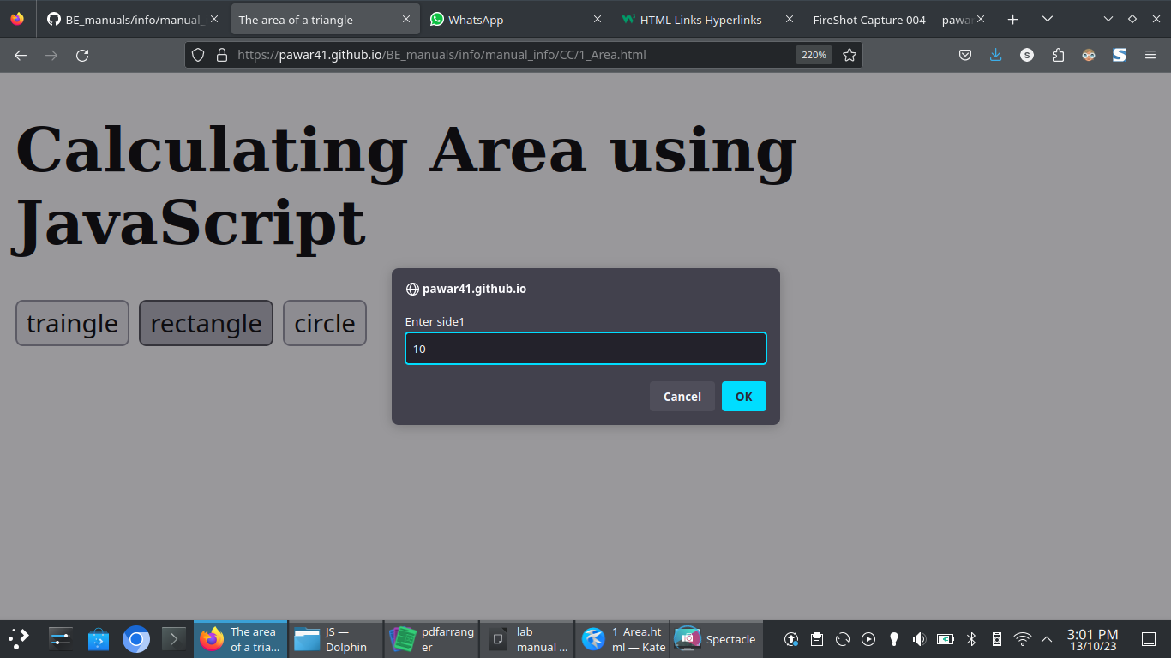

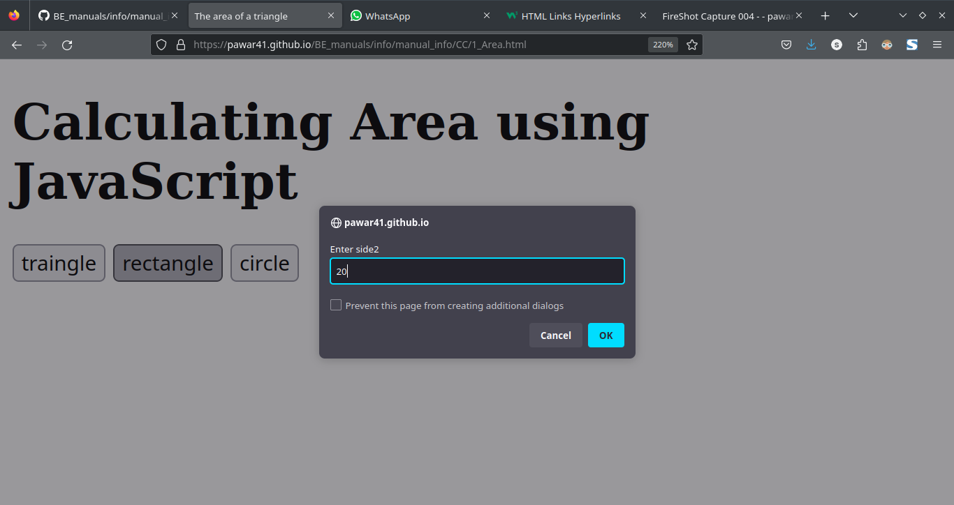

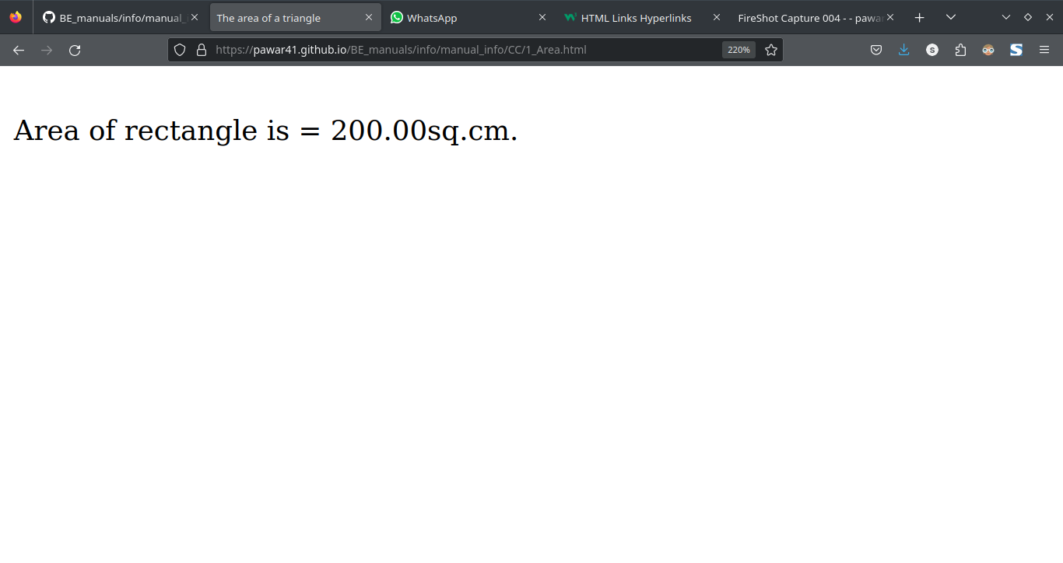

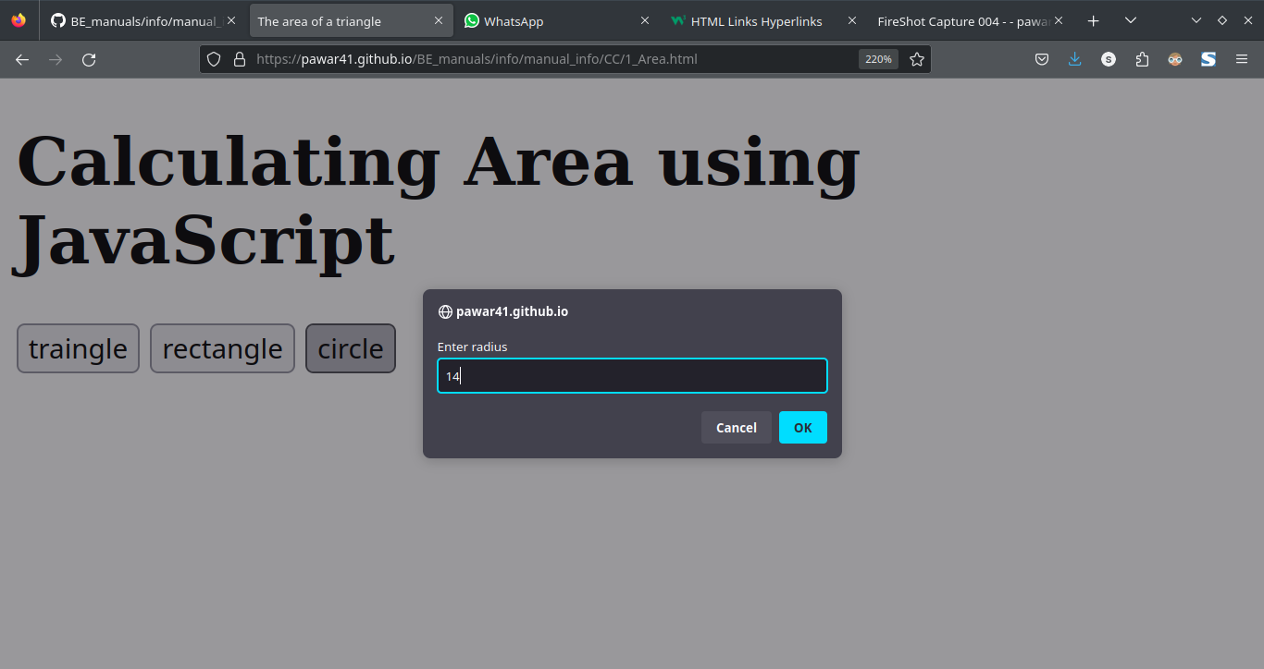

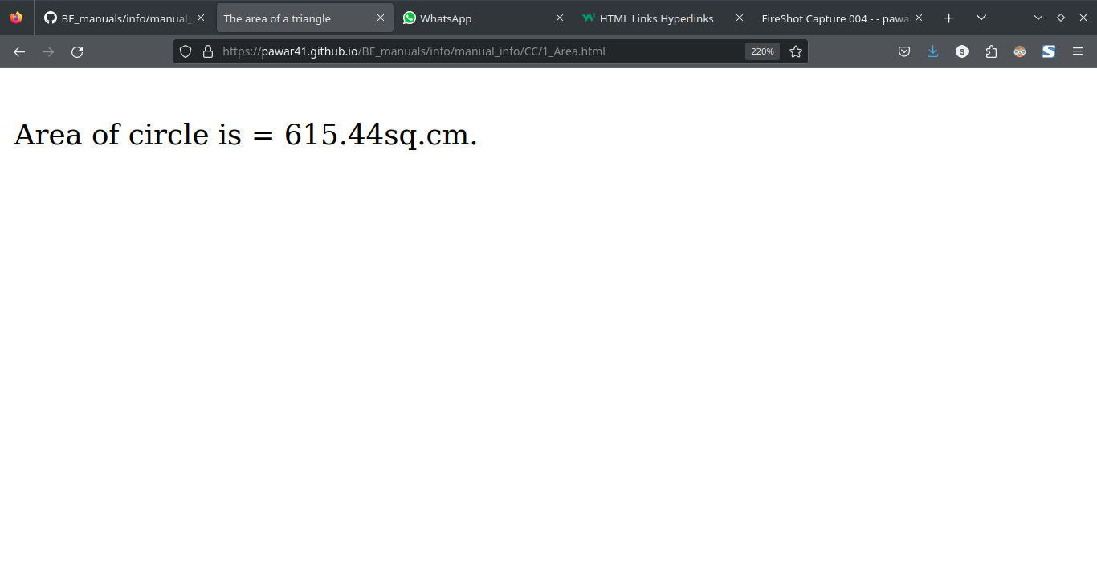**Conclusion:**

**Experiment No: 02**

**Aim:-** Write a JavaScript program to generate the multiplication table of a given number

**Algorithm :**

**Program Code:**

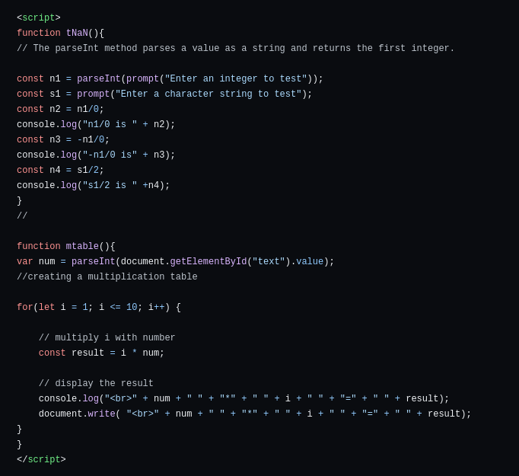

**Output:**

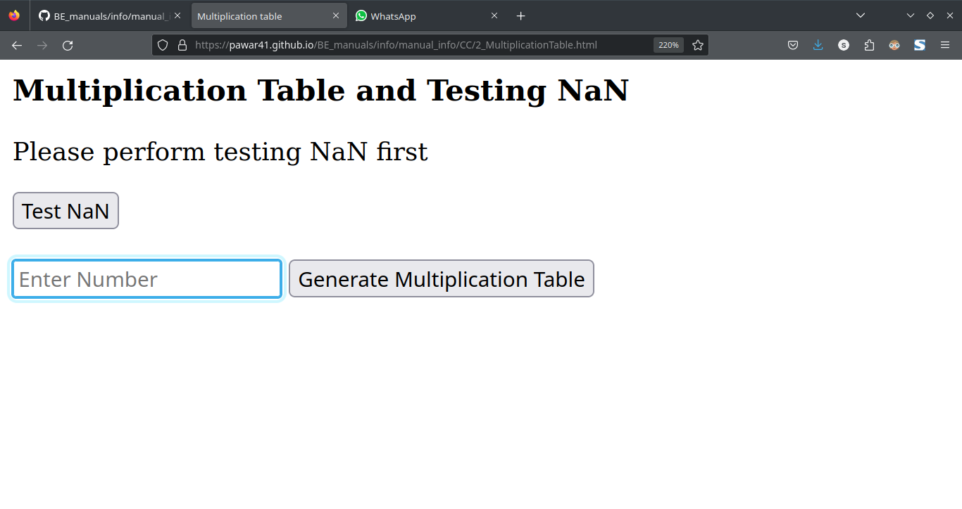

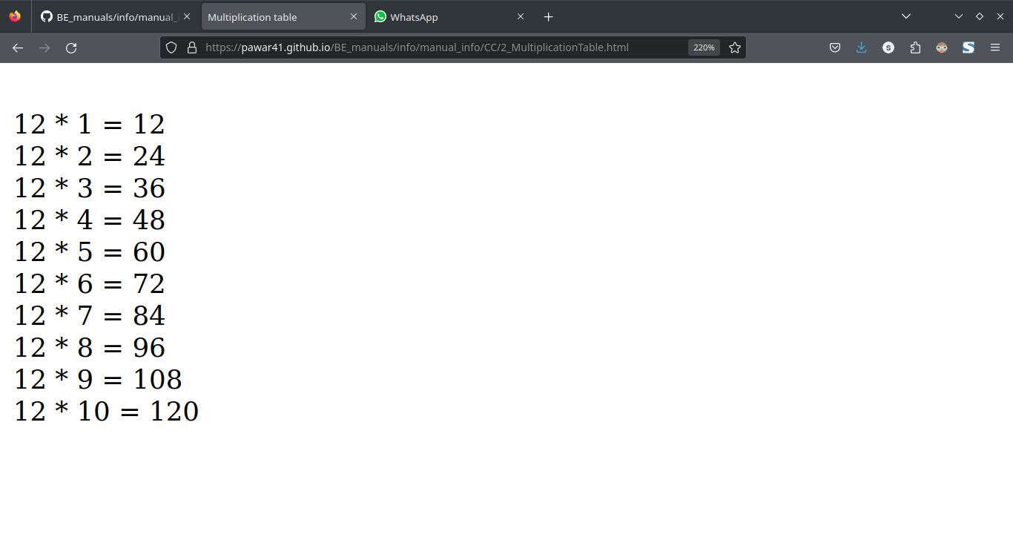

**Conclusion:**

**Experiment No: 03**

**Aim:-** Write a JavaScript program to following operations on a given string,

• Reverse string

• Replace characters of a string.

• String is Palindrome

**Theory:**

**reverse() Method:**

JavaScript 1.1+ and JScript 2.0+ also allow you to reverse the elements of the array in place. The reverse() method, as one might expect, reverses the elements of the array it is invoked on:

var myArray = ["red", "green", "blue"];

myArray.reverse();

alert(myArray);

**replace()**

The replace() method returns the string that results when you replace text matching its first argument (a regular expression) with the text of the second argument (a string). If the g (global) flag is not set in the regular expression declaration, this method replaces only the first occurrence of the pattern. For example,

var s = "Hello. Regexps are fun.";

s = s.replace(/\./, "!"); // replace first period with an exclamation pointalert(s);

produces the string ―Hello! Regexps are fun.‖ Including the g flag will cause the interpreter to perform a global replace, finding and replacing every matching substring. For example,

var s = "Hello. Regexps are fun.";s = s.replace(/\./g, "!"); // replace all periods with exclamation pointsalert(s);

yields this result: ―Hello! Regexps are fun!‖

**Algorithm :**

**Program Code:**

**Output:**

**Conclusion:**

**Experiment No: 04**

**Aim:-** Write a JavaScript program to compare two strings using various methods.

**Theory:**

**Comparing Strings**

While it is clear what comparison operators mean for numbers, what about strings? For example, is the following expression true? "thomas" >> "fritz"

When you compare strings, JavaScript evaluates the comparison based on strings‘ lexicographic order. Lexicographic order is essentially alphabetic order, with a few extra rules thrown in to deal with upper- and lower-case characters as well as to accommodate strings of different lengths.

The following general rules apply:

* Lowercase characters are less than uppercase characters.
* Shorter strings are less than longer strings.
* Letters occurring earlier in the alphabet are less than those occurring later.
* Characters with lower ASCII or Unicode values are less than those with larger values.

The interpreter examines strings on a character-by-character basis. As soon as one of the previous rules applies to the strings in question (for example, the two characters are different), the expression is evaluated accordingly.

The following comparisons are all true: "b" >> "a"

"thomas" >> "fritz"

"aaaa" >> "a"

"abC" >> "abc"

While this ordering might seem confusing at first blush, it is quite standard and consistent across most programming languages.

Algorithm :

**Program Code:**

**Output:**

**Conclusion:**

**Experiment No: 05**

**Aim:-** Write a JavaScript program that will create a countdown timer

**Algorithm :**

**Program Code:**

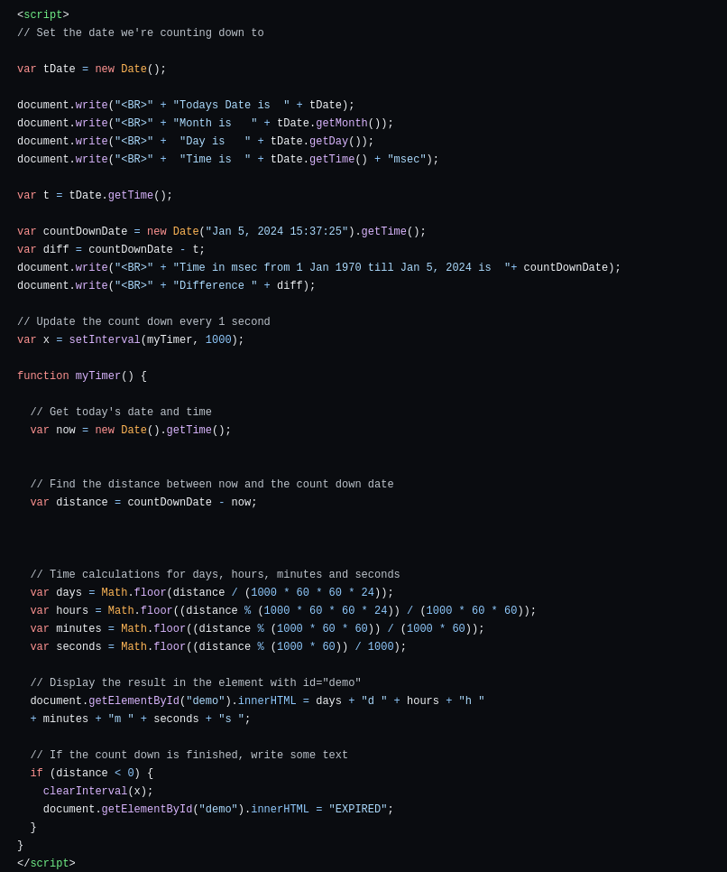

**Output:**

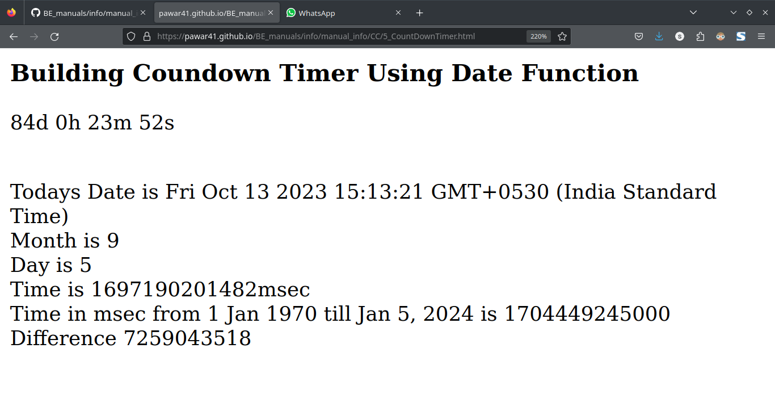

**Conclusion:**

**Experiment No: 06**

**Aim:-** Write a JavaScript program that will create an array and perform following operations

• To remove specific element from the array.

• Check if an array contains a specified value.

• To empty an array

**Algorithm :**

**Program Code:**

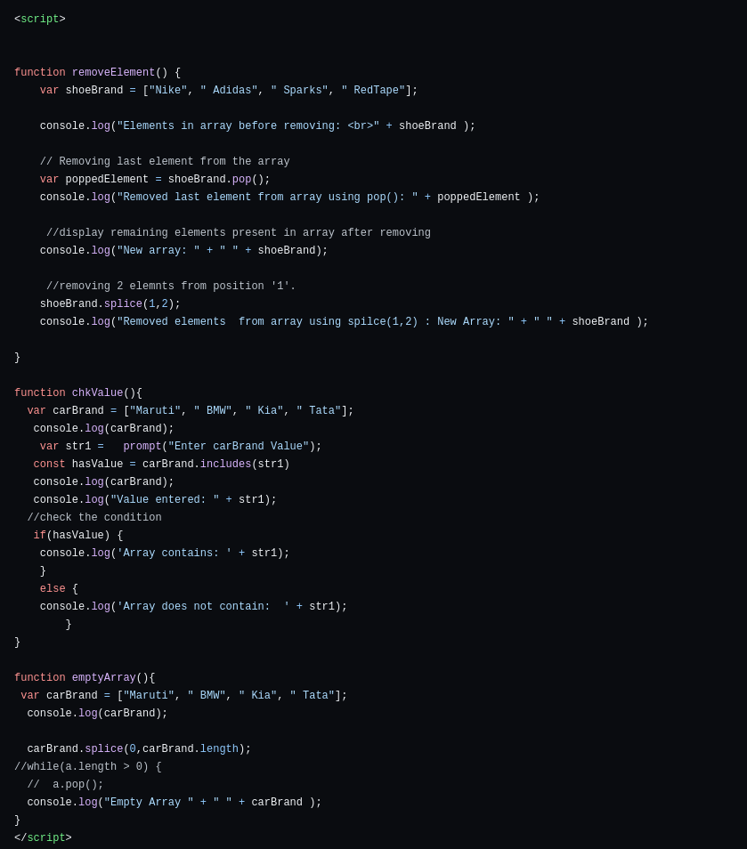

**Output:**

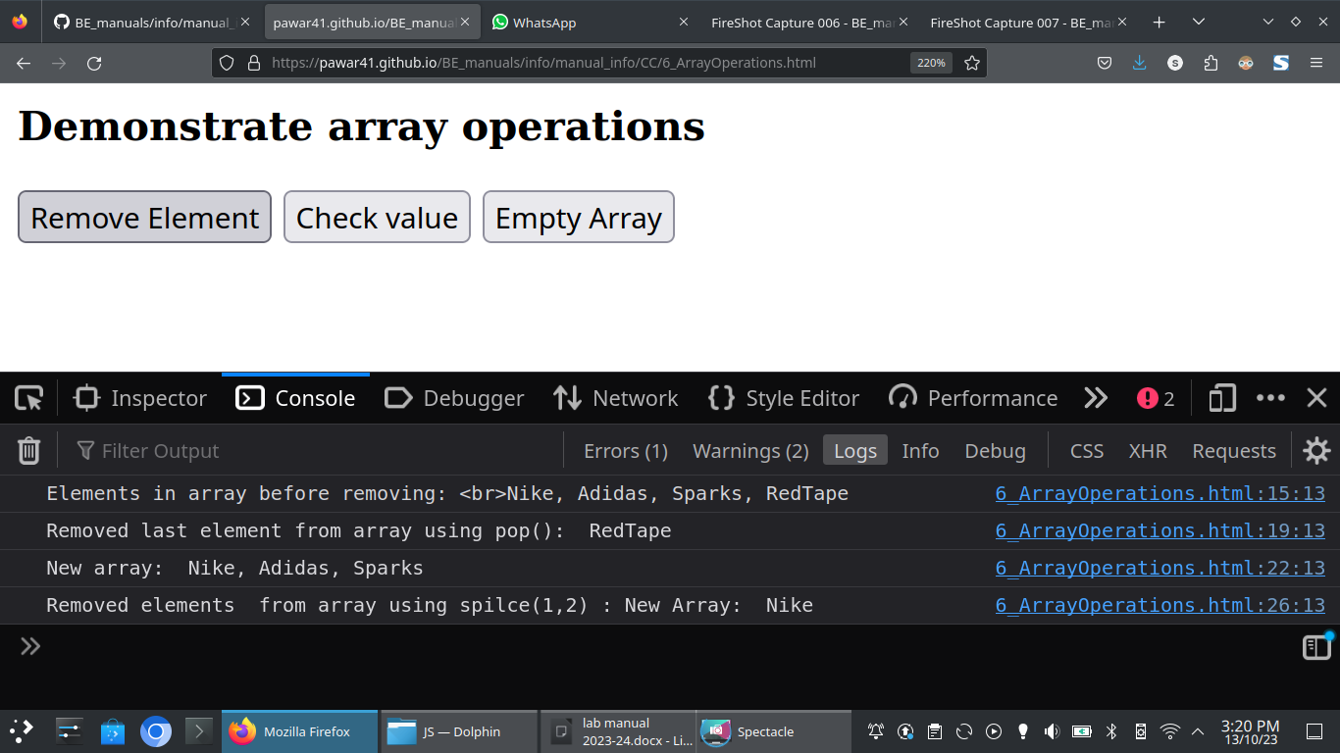

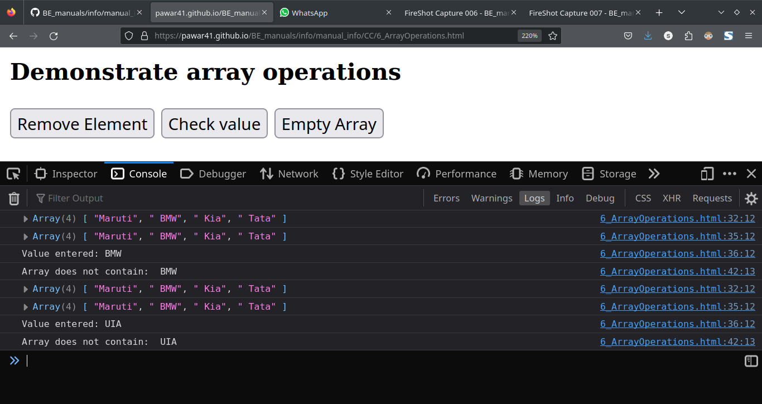

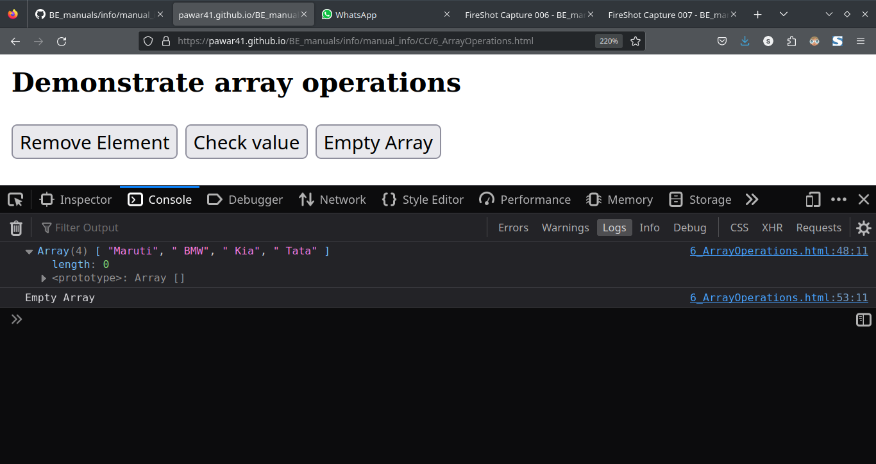

**Conclusion:**

**Experiment No: 07**

**Aim:-** Write a JavaScript program that will append an object to an array and will check if an object is an array

**Algorithm :**

**Program Code:**

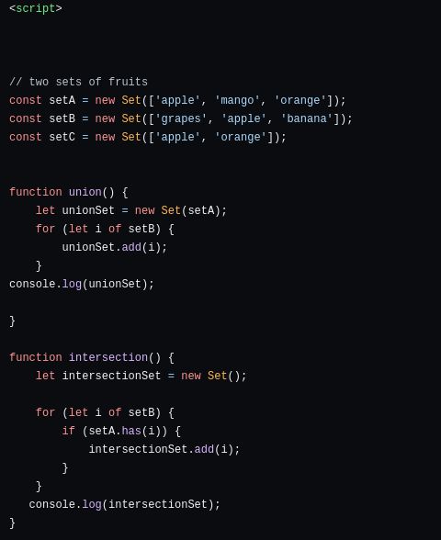

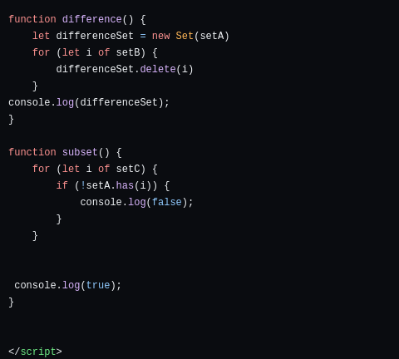

**Output:**

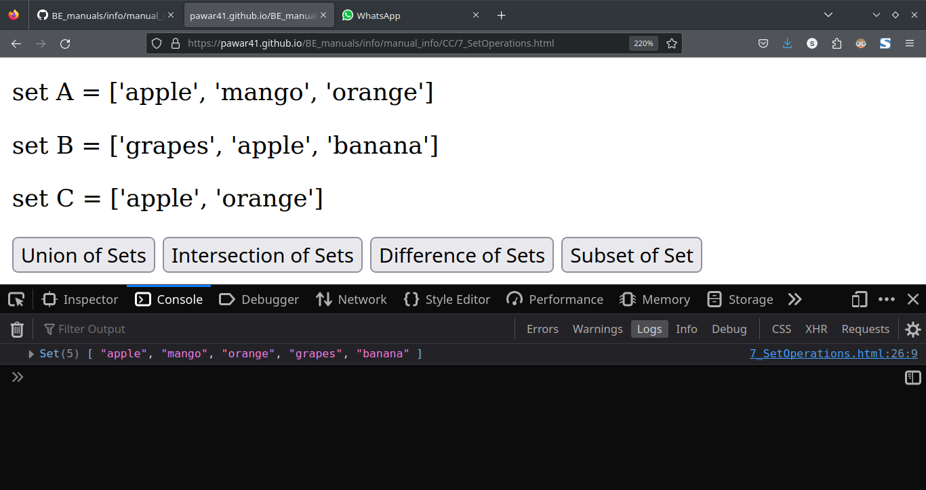

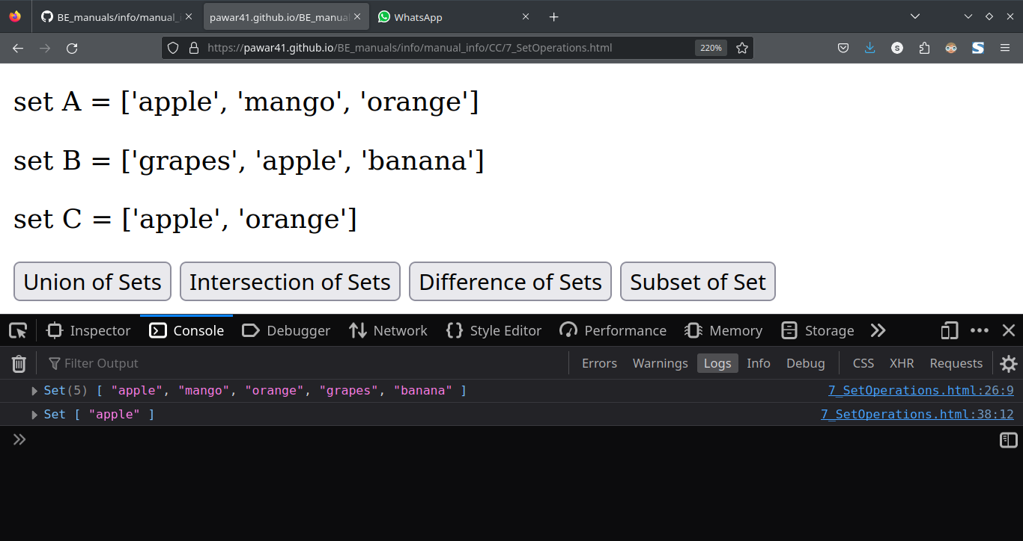

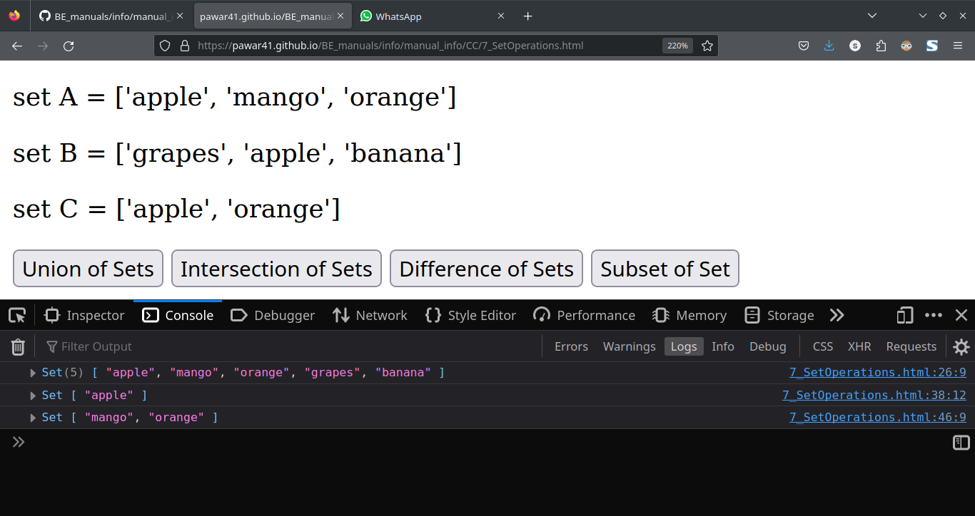

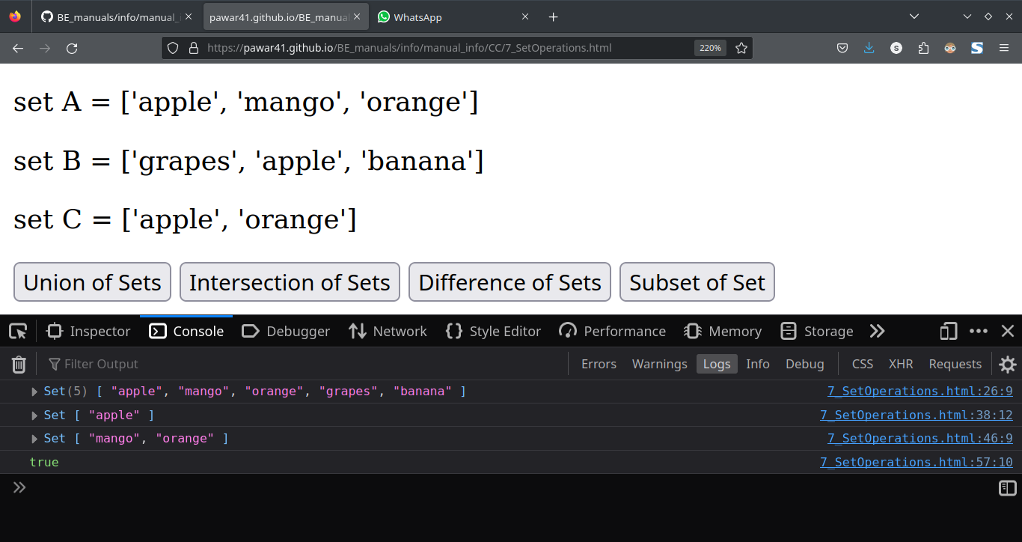**Conclusion:**

**Experiment No: 08**

**Aim:-** Write a JavaScript program to create a Home page of any website and change background color using

• On mouse over event

• On focus event

**Algorithm :**

**Program Code:**

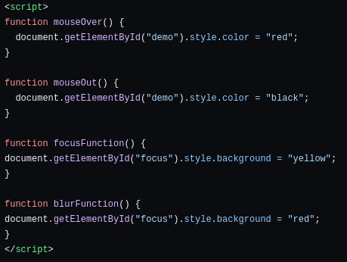

**Output:**

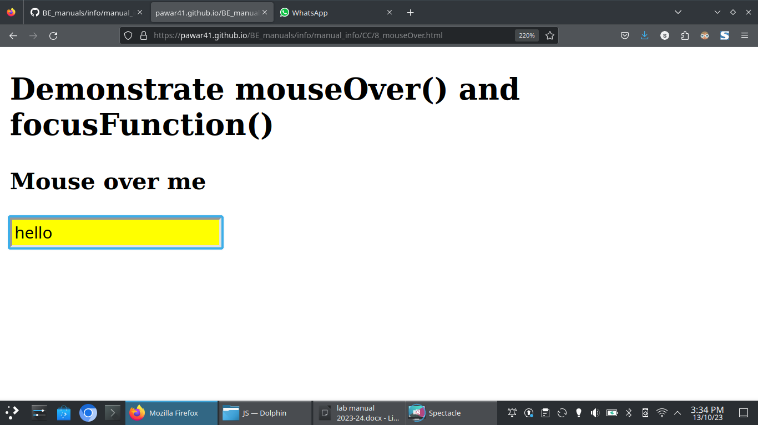

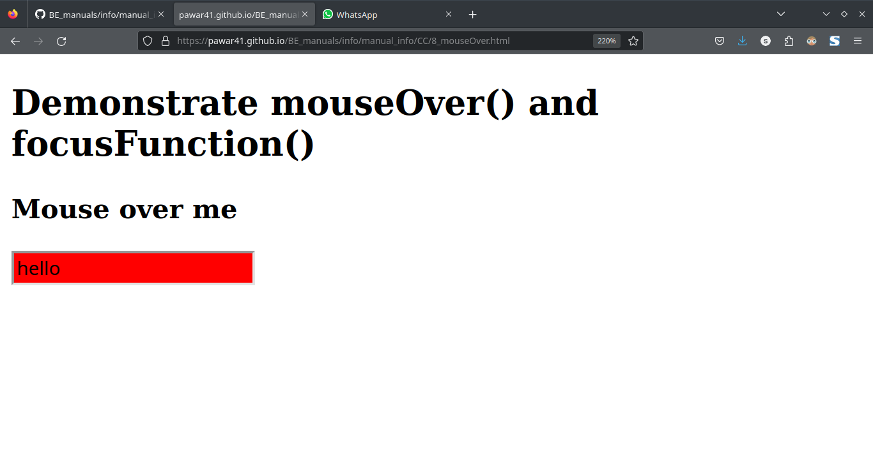**Conclusion:**

**Experiment No: 09**

**Aim:-**

Design and implement a simple calculator using Java script for operations like addition multiplication, subtraction, division, square of a number etc:

• Design a calculator like text field for input and output, buttons for numbers and operations etc.

• Validate input values

• Prompt / Alerts for invalid values etc.

**Algorithm :**

**Program Code:**

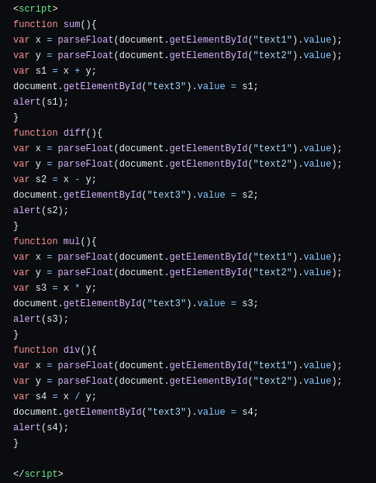

**Output:**

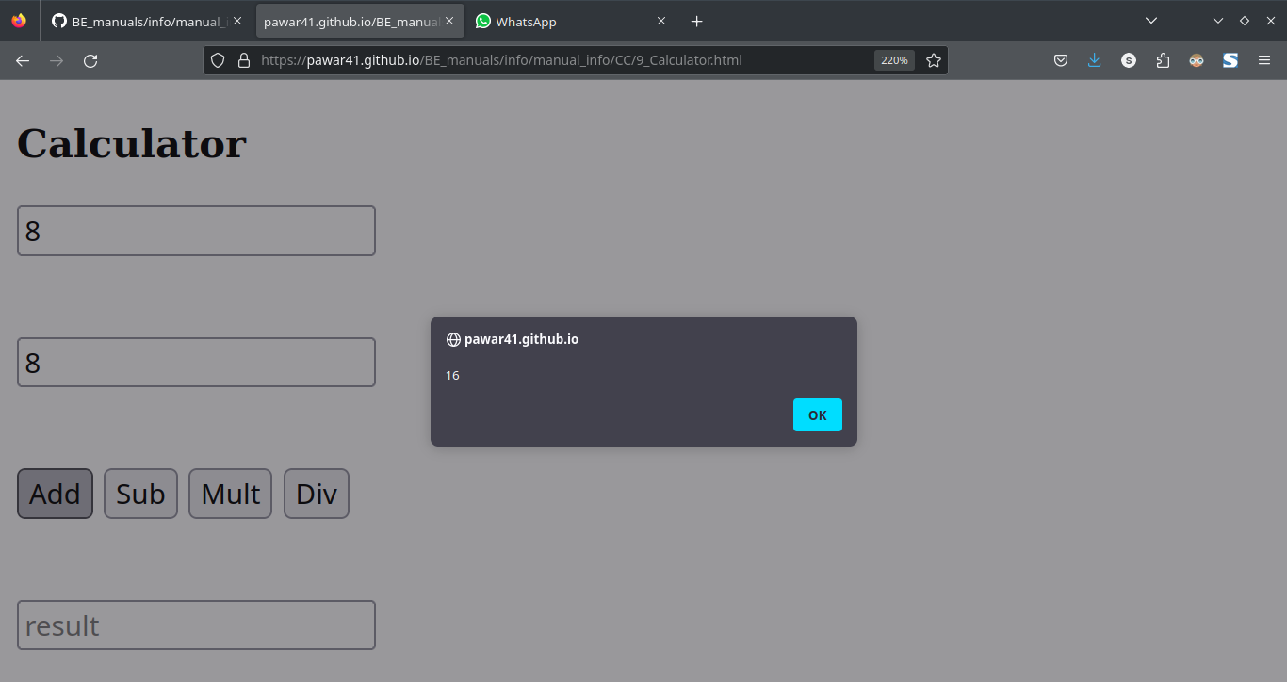

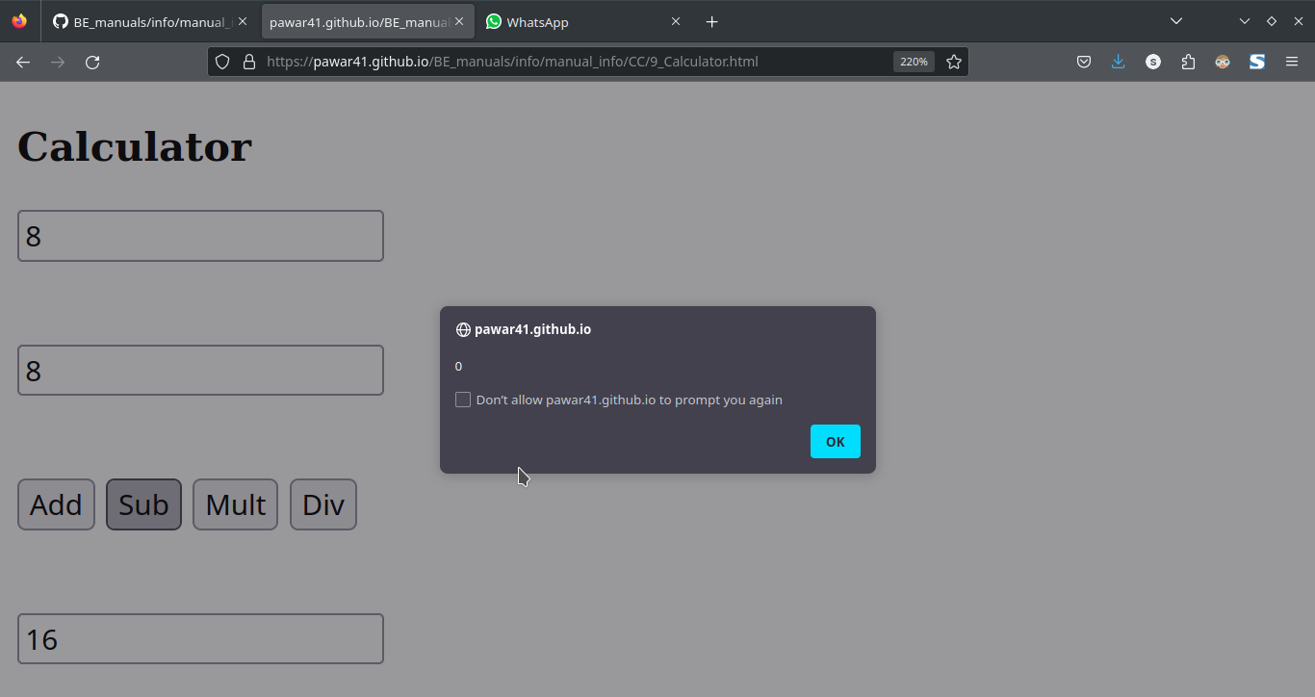

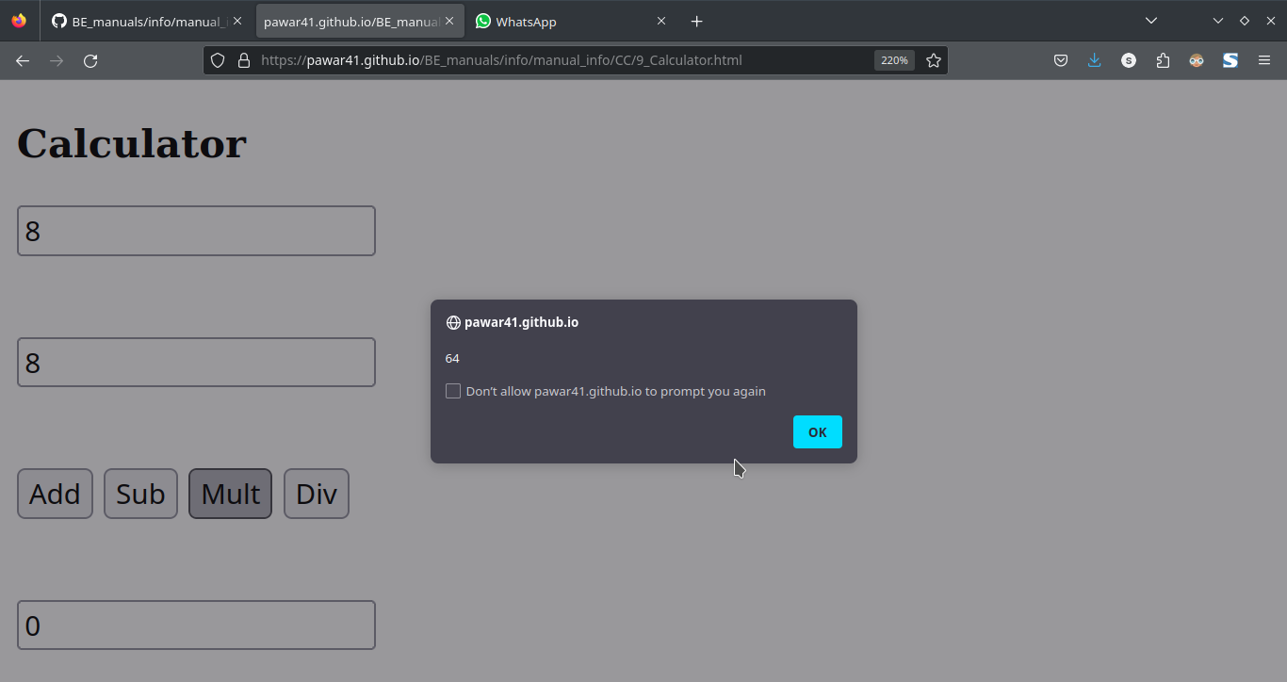

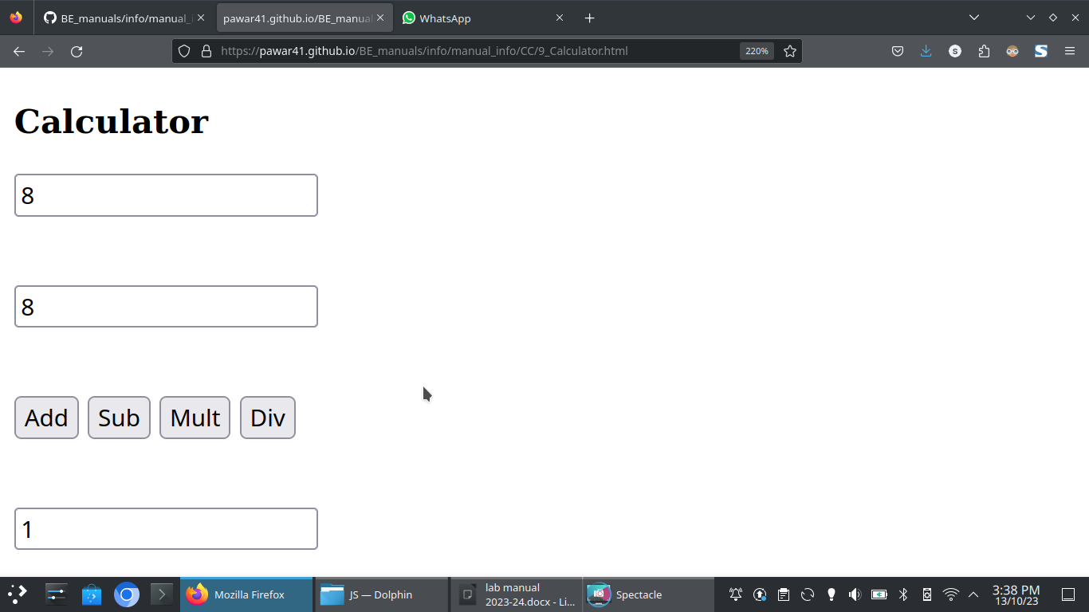

**Conclusion:**

**Programs**

**Experiment No 1**

**JavaScript Lab 1**

Write a JavaScript program to calculate area of triangle, area of rectangle and area of circle

**Index.html**

<!DOCTYPE html>

  <head>

    <scriptsrc="https://cdnjs.cloudflare.com/ajax/libs/p5.js/0.9.0/p5.min.js"></script>

  </head>

  <body>

    <script src="sketch.js"></script>

  </body>

</html>

**Sketch.js**

//Area of circle

var r=10;

varareac=3.141*r*r

console.log(areac)

//Area of Triangle

var base=10;

var height=10;

varareat=(base*height) /2

console.log(areat)

//Are of Rectangle

var width=20;

var height2=20

vararear=width*height2;

console.log(arear)

**Experiment No.2**

**JavaScript Lab 2**

Write a JavaScript program to generate the multiplication table of a given number

**Method 1 Preferable**

**Index.html**

<!DOCTYPE html>

  <head>

    <scriptsrc="https://cdnjs.cloudflare.com/ajax/libs/p5.js/0.9.0/p5.min.js"></script>

  </head>

  <body>

    <script src="sketch.js"></script>

  </body>

</html>

**sketch.js**

//to generate multipliication table of given number Method 1

var num = prompt("Enter a number")

console.log(num)

var table=1;

for(var i=1;i<=10;i++){

    table=num*i;

    console.log(table)

}

**Method 2**

**Index.html**

<!DOCTYPE html>

  <head>

    <script src="https://cdnjs.cloudflare.com/ajax/libs/p5.js/0.9.0/p5.min.js"></script>

  </head>

  <body>

    <script src="sketch.js"></script>

    <form>

        <label for="uname">Choose a username: </label>

        <input type="text" id="uname" placeholder="Enter Value..">

        <button onclick="getInputValue()">Submit</button>

    </form>

  </body>

</html>

**Sketch.js**

function getInputValue(){

    var num1=document.getElementById("uname").value;

    var table1=1;

    for(var j=1;j<=10;j++){

        table1=num1*i;

        console.log(table1)

}

}

**Experiment No : 3**

**JavaScript Lab 3**

Write a JavaScript program that will append an object to an array and will check if object is an array.

**Index.html**

<!DOCTYPE html>

  <head>

    <script src="https://cdnjs.cloudflare.com/ajax/libs/p5.js/0.9.0/p5.min.js"></script>

    <script src="sketch.js"></script>

  </head>

  <body>

<script >

</script>

  </body>

</html>

**Sketch.js**

// program to append an object to an array

function insertObject(arr, obj) {

    //Append Object to Array Using push()

    arr.push(obj);

    console.log(arr);

    /*

    //Append Object to Array Using splice()

    let index = arr.length;

    arr.splice(index, 0, object);

    //Append Object Using Spread Operator

    // append object

    arr = [...arr, object];

    console.log(arr);

    */

}

function checkObject(arr) {

    // check if arr is array

    const result = Array.isArray(arr);

    if(result) {

        console.log("The Object is an array.");

    }

    else {

        console.log("The Object is not an array.");

    }

}

// original array

var array = [1, 2, 3];

// object to add

//var object = {x: 12, y: 8};

var object = ["Thoms", "Banana"];

// call the function

insertObject(array, object);

checkObject(object)

**Experiment No. 4**

**JavaScript Lab 4**

Write a JavaScript program that will create an array and perform following operations

1) To remove specific elements from array

2) Check if array contains specific value

3) To empty an array

**Extra Operations**

**Pop, push, shift, delete, concatenate, Max and Min, Sorting Arrays, slice()**

**1) To remove specific elements from array**

Using  splice()

The first parameter defines the position where new elements should be **added** (spliced in). The second parameter defines **how many** elements should be **removed**.

<!DOCTYPE html>

  <head>

    <script src="https://cdnjs.cloudflare.com/ajax/libs/p5.js/0.9.0/p5.min.js"></script>

  </head>

  <body>

<script>

// JavaScript code to illustrate splice() function

var arr =  ["Banana", "Orange", "Apple", "Mango"];

document.write("Original  Array: " + arr + "<br>");

function delete() {

    // Removing the specified element from the array

    var element= prompt("Enter the array element to be removed!");

    var flag=0;

    for(var i=0;i<=arr.length;i++){

      if(arr[i]==element){

      var spliced = arr.splice(i, 1);

      document.write("Removed element: " + spliced + "<br>");

      document.write("Remaining elements: " + arr);

      flag=1;

      break;

    }

  }

    if(flag==0){

      document.write("Element Not Found");

    }

}

delete();

</script>

  </body>

</html>

**2) Check if array contains specific value**

<!DOCTYPE html>

  <head>

    <script src="https://cdnjs.cloudflare.com/ajax/libs/p5.js/0.9.0/p5.min.js"></script>

  </head>

  <body>

<script>

// JavaScript code to illustrate splice() function

var arr =  ["Banana", "Orange", "Apple", "Mango"];

document.write("Original  Array: " + arr + "<br>");

function search(){

   // Searching specified element from the array

   var element= prompt("Enter the array element to be Searched!");

    var flag=0;

    for(var i=0;i<=arr.length;i++){

      if(arr[i]==element){

      document.write("Element found at position  " + (i+1) +"<br>");

      flag=1;

      break;

    }

  }

    if(flag==0){

      document.write("Element Not Found!");

    }

}

search();

</script>

  </body>

</html>

**3) TO Empty Array**

<!DOCTYPE html>

  <head>

    <script src="https://cdnjs.cloudflare.com/ajax/libs/p5.js/0.9.0/p5.min.js"></script>

  </head>

  <body>

<script>

// JavaScript code to illustrate splice() function

var arr =  ["Banana", "Orange", "Apple", "Mango"];

document.write("Original  Array: " + arr + "<br>");

function arrayEmpty(){

  arr.splice(0,arr.length);

  if(arr.length==0){

    document.write("Array is Empty"+"<br>");

  }

  /*

  //Method 2

  arr=[];

  if(arr.length==0){

    document.write("Array is Empty"+"<br>");

  }

  //Method 3

  while(arr.length > 0) {

    arr.pop();

}

if(arr.length==0){

    document.write("Array is Empty"+"<br>");

  }

// Method 4

arr.length = 0;

if(arr.length==0){

    document.write("Array is Empty"+"<br>");

  }

*/

}

arrayEmpty();

</script>

  </body>

</html>

**User driven:**

**sketch1.js**

// JavaScript code to illustrate splice() function

var arr =  ["Banana", "Orange", "Apple", "Mango"];

document.write("Original  Array: " + arr + "<br>");

function checkInput(){

    var ip = document.getElementById('contact').value;

    for(var j=1;j<=1;j++){

    if(ip==1){

        deleteElement();

    }

    else if(ip==2){

        Search();

    }

    else if(ip==3){

        arrayEmpty();

    }

    else{

        alert("Enter Valid input!");

    }

}

}

function deleteElement() {

    // Removing the specified element from the array

    var element= prompt("Enter the array element to be removed!");

    var flag=0;

    for(var i=0;i<=arr.length;i++){

      if(arr[i]==element){

      var spliced = arr.splice(i, 1);

      alert("Removed element: " + spliced);

      alert("Remaining elements: " + arr);

      flag=1;

      break;

    }

  }

    if(flag==0){

      alert("Element Not Found!");

    }

}

function Search(){

   // Searching specified element from the array

   var element= prompt("Enter the array element to be Searched!");

    var flag=0;

    for(var i=0;i<=arr.length;i++){

      if(arr[i]==element){

      alert("Element found at position  " + (i+1));

      flag=1;

      break;

    }

  }

    if(flag==0){

      alert("Element Not Found!");

    }

}

function arrayEmpty(){

  arr.splice(0,arr.length);

  if(arr.length==0){

    alert("Arrray emptied successfully!");

  }

  /*

  //Method 2

  arr=[];

  if(arr.length==0){

     alert("Arrray emptied successfully!");

  }

  Method 3

  while(arr.length > 0) {

    arr.pop();

}

if(arr.length==0){

     alert("Arrray emptied successfully!");

// Method 4

arr.length = 0;

if(arr.length==0){

    alert("Arrray emptied successfully!");

  }

*/

}

**Index.html**

<!DOCTYPE html>

  <head>

    <script src="https://cdnjs.cloudflare.com/ajax/libs/p5.js/0.9.0/p5.min.js"></script>

    <script src="sketch1.js"></script>

  </head>

  <body>

    <p>1. Enter 1 to Remove specific element from array</p>

    <p>2. Enter 2 to search for specific element in an array</p>

    <p>3. Enter 3 to Empty the Array</p>

    <div>

      <input type="text" id="contact"/>

      <button onClick="checkInput();">Submit</button>

      </div>

<script >

</script>

  </body>

</html>